DESIGN AND IMPLEMENTATION OF – “SUSTAIN WORLD :- THE SMART HUB”

PROJECT REPORT

SUBMITTED IN PARTIAL FULFILLMENT OF THE REQUIREMENT FOR THE AWARD OF DIPLOMA IN ELECTRONICS & TELECOMMUNICATION ENGINEERING.

SUBMITTED BY -

SHAIKH JIYA JAINUDDIN

UNDER THE GUIDANCE OF
Prof. Ram Sharma.



DEPARTMENT OF ELECTRONICS & TELECOMMUNICATION GOVERNMENT POLYTECHNIC, KARAD (2024-25)

GOVERNMENT POLYTECHNIC, KARAD

CERTIFICATE
This is to certify that,
SHAIKH JIYA JAINUDDIN (2200100287)

of final year Electronics & Telecommunication Engineering students have completed project of final year having title “SUSTAIN WORLD: THE SMART HUB” during academic session 2024-2025 as a part of project work described by Government Polytechnic, Karad for partial fulfilment for the Diploma in Electronics and Telecommunication Engineering in the sixth semester. The project work is the record of student’s own work under my guidance and to my satisfaction.

Prof. Ram Sharma Prof. U.S.Rangate
(Project Guide) Head Department
of E&TC Engineering

Dr. S.A.Patil
(Principal)

GOVERNMENT POLYTECHNIC, KARAD CANDIDATE'S DECLARATION

I hereby certify that the work which is being presented in the project report entitled “SUSTAIN WORLD: THE SMART HUB” by us in partial fulfilment of requirement for the award of diploma in Electronics and Telecommunication Engineering submitted in the department of Electronics and Telecommunication Engineering is an authentic record of our own work carried out during even (2024-25) guided by Prof. Ram Sharma.

Signature and Name of the Students

Shaikh Jiya Jainuddin

This is to certify that the above statement made by the candidate is correct to the best of our knowledge.

Signature of the Guide

ACKNOWLEDGEMENT

First and foremost, we would like to express our immense gratitude towards our institution Government Polytechnic Karad, which helped us to attain profound technical skills in the field of Electronics and Telecommunication, thereby fulfilling our most cherished goal. We take it as an opportunity to thank all who directly and indirectly inspired, directed and assisted us towards successful completion of this project report. We express our sincere thanks to the principal, Dr. S. A. Patil & the Head of Department Prof. U. S. Rangate for having us allowed to submit this report as part of our academics.
We would like to thank Prof. Ram Sharma of lecturer in Electronic and Telecommunication department, Government Polytechnic Karad for encouragement throughout the project and guideline in designing and working out this project. We are also grateful to team of “Sustain World: The Smart Hub” for their highly encouraging and co-operative attitude. We express our friends and parents for their moral support during project.

Date- / / 2024

Place- Government Polytechnic, Karad

Your sincerely :

Shaikh Jiya Jainuddin (165494)

CONTENTS
Certificate .................................................................................................................................

Candidate’s declaration ...........................................................................................................

Acknowledgement....................................................................................................................

Chapter 1 Introduction
  - Introduction 02
  - Motivation 02
  - Problem Statement 03-04
  - Objective 05
Chapter 2 Literature Survey
  - Literature Survey 06
  - Theoretical Background 06-08
Chapter 3 Scope of Project
  - Scope of project 09
Chapter 4 System Design
  - Block diagram 10
  - Flow chart 11-13
  - Description 14-20
Chapter 5- System Implementation
  - Circuit Diagram and working 21-22
  - Details/ Procedure of software 23
  - Program of the Project 24-30

Chapter 6- Result and Applications

  - Result 31
  - Applications 31

Chapter 7- Concluision and future scope

  - Concluision 32

  - Advantages 32

  - Limitations 32

  - Future Scope 33

Chapter 8- Reference and Bibliography

  - Bibliography and Reference 34

Chapter 9 - Appendix
  - Datasheet 35

LIST OF FIGURES

Sr. No | Name of Figure | Page No
1 | System Design | 10 - 13
2 | Arduino | 14
3 | IR Sensor | 14
4 | Ultrasonic Sensor | 15
5 | Piezoelectric sensor | 15
6 | Motor | 16
7 | L293D Motor Driver | 16
8 | Water pump | 17
9 | Switch | 17
10 | Gears | 18
11 | Solar Pannel | 18
12 | LCD 16 X2 | 19
13 | LM358 Comparator IC | 19
14 | LED | 20
15 | System Implementation | 21

CHAPTER 1 : INTRODUCTION

Introduction.

This project explores the integration of multiple innovative applications that combine energy harvesting, entertainment, and smart technologies. These applications include an advertisement section, child gaming systems powered by footstep energy, footstep-based electricity generation systems, and smart dustbins. The literature review focuses on existing research and technologies related to each of these components.

Smart Dustbin: -
The smart dustbin is designed in the way that it will be used to beat the Indian mentality and make its own use properly. Means whenever it’s installed in the mall’s, hospital’s & colleges etc. The people take their own interest to throw the garbage into dustbin because whenever they throw the dust automatically dustbin open its mouth take garbage under it and in return it gives you water cold-drink etc.

Child Entertainment with memory mapping game: -
The child entertainment section is consist of game which is designed in such way that child not only used to enjoy or entertain but also map their brain with simultaneously the electricity gates generate with the footstep electricity generating floor.

Footstep based electricity generation system:-
The floor in the Entire system is designed in the way that is used to generate Energy whenever Anybody Walk on it. And that energy will be gate stored into batteries on which everything will be work by using that stored energy.

Advertisement Section:-
The advertisement section is section which is for helping to promote businesses of youth. With smart and short process and mass advertisement of businesses in the rushed area.
From anywhere in the world.

Motivation

he motivation behind this project is to bridge the gap between sustainability, technology, and user engagement by integrating energy harvesting with smart and interactive applications. The key driving factors include:

Sustainable Energy Utilization:
  - Harnessing footstep-based electricity generation to promote clean and renewable energy solutions.
  - Reducing dependency on conventional power sources and utilizing human movement as an alternative energy source.

Encouraging Cleanliness through Smart Innovation:
  - Addressing the Indian mentality regarding waste disposal by making garbage disposal more interactive and rewarding.
  - Motivating people to use smart dustbins by offering small incentives such as water or cold drinks.

Enhancing Child Development through Smart Entertainment:
  - Merging entertainment and cognitive development with a memory-mapping game that also contributes to electricity generation.
  - Encouraging physical activity while promoting learning through gamification.

Supporting Youth Entrepreneurship and Smart Advertisement:
  - Providing an efficient and cost-effective advertising platform in crowded public spaces.
  - Enabling businesses to reach wider audiences through a tech-driven, mass advertisement system.

Futuristic Smart Cities Concept:
  - Aligning with smart city initiatives by introducing interactive, self-sustaining solutions for urban environments.
  - Enhancing public spaces with energy-efficient, technology-integrated systems that benefit individuals and businesses alike.
By integrating footstep-based energy harvesting, smart utilities, and interactive technology, this project aims to create an eco-friendly, tech-driven, and user-centric environment that fosters sustainability and innovation.

Statement of Problem.

In today’s world, energy scarcity, improper waste management, lack of interactive child development systems, and inefficient advertising methods are major challenges. Conventional energy sources are depleting, and there is a growing need for sustainable and innovative solutions that integrate multiple aspects of daily life.

Energy Waste in Public Spaces:
  - Human movement in crowded areas like malls, hospitals, and colleges generates untapped kinetic energy, which could be harnessed to produce electricity. However, there is no efficient system to capture and utilize this energy.

Ineffective Waste Management & Public Awareness:
  - Improper waste disposal remains a persistent issue, especially in urban areas.
  - Traditional dustbins often go unused due to negligence, requiring a more engaging and incentive-driven approach to encourage cleanliness.

Lack of Interactive & Productive Child Entertainment:
  - Many digital and mobile-based games limit physical activity and cognitive development.
  - There is a need for a fun, interactive game that enhances memory and brain mapping while also contributing to energy generation.
Limited and Costly Advertisement Opportunities:
Traditional advertising methods in public areas are costly, static, and lack dynamic engagement.
  - Businesses, especially startups and young entrepreneurs, struggle with affordable, high- visibility advertisement options.

Problem Statement:

There is a need for a multi-functional, technology-driven system that integrates energy harvesting, smart waste management, child-friendly interactive entertainment, and innovative advertising.
This project aims to develop a footstep-powered smart floor system that not only generates electricity but also incorporates a self-operating smart dustbin, an interactive gaming experience for children, and a cost-effective digital advertisement platform. By doing so, it addresses sustainability, cleanliness, entertainment, and business promotion challenges in urban spaces.
This system will contribute to energy conservation, improve waste disposal habits, enhance cognitive development in children, and provide a smart advertising solution, aligning with the goals of sustainable smart cities.

Objective of Study.
This study aims to develop and implement a multi-functional, energy-efficient system that integrates footstep-based electricity generation, smart waste management, child-friendly interactive gaming, and an innovative advertisement platform. The key objectives are:

- To Develop a Footstep-Based Energy Harvesting System:
  - Design a floor that converts human footsteps into usable electrical energy.
  - Store the generated energy in batteries for powering smart applications.
  - Evaluate the efficiency and feasibility of piezoelectric and solar energy integration.
- To Design and Implement a Smart Dustbin:
  - Create an automated, sensor-based dustbin that opens when garbage is detected.
  - Introduce an incentive mechanism (e.g., dispensing water or cold drinks) to encourage proper waste disposal.
  - Promote awareness and improve cleanliness habits in public spaces.
- To Develop an Interactive Child Gaming System with Memory Mapping:
  - Design a footstep-powered gaming system that engages children in physical activity.
  - Enhance cognitive skills by integrating a memory-mapping mechanism.
  - Utilize the electricity generated by the footstep floor to power the gaming system.
- To Establish a Smart Advertisement Platform:
  - Develop a cost-effective and technology-driven advertisement system.
  - Allow businesses to remotely upload advertisements in high-footfall areas.
  - Provide real-time, dynamic ad displays to maximize business outreach.
- To Promote Sustainable and Smart City Initiatives:
  - Encourage energy conservation and sustainability through innovative technology.
  - Integrate smart solutions into public spaces such as malls, hospitals, and colleges. Contribute to the vision of self-sustaining, technology-driven urban environments.
By achieving these objectives, the study demonstrates the practical application of energy harvesting, improves waste management, enhances child learning experiences, and supports smart business marketing solutions.

CHAPTER 2 : LITERARTURE SURVEY.

Literature survey on Sustain World :- the smart hub :

Sustain World :- the smart hub hold immense potential to revolutionize youth by improving efficiency, reducing costs, and promoting sustainable practices. However, their widespread adoption depends on addressing challenges related to cost, adaptability, and environmental impact. Further research is essential to make Sustain World :- the smart hub accessible and practical for Youth worldwide.
    - Key technologies in our project :

his project integrates multiple innovative technologies to create a self-sustaining, interactive, and energy-efficient system. The key technologies used are:

Footstep-Based Energy Harvesting Technology
  - Piezoelectric Sensors:
Converts mechanical pressure from footsteps into electrical energy.

Kinetic Energy Harvesting:
Utilizes movement-based energy generation to power applications.

Battery Storage System:
Stores generated electricity for future use in smart applications.

Smart Waste Management System
  - Ultrasonic & Infrared Sensors:
Detects waste presence and triggers the automatic opening of the dustbin.

Microcontroller (Arduino):
Processes sensor data and controls the bin’s automated functions.

Reward Dispensing Mechanism:
Dispenses incentives (e.g., water/cold drinks) when users dispose of garbage correctly.

Interactive Gaming System with Memory Mapping
  - Led and switch:-
LED will emits Randomly and swich Should used to turn off.

Embedded System & IoT:
Processes real-time data to track child activity and enhance engagement.

Memory Mapping Algorithm:
Enhances cognitive skills by linking movement patterns with learning modules.

Smart Advertisement System
  - Cloud-Based Digital Display System:
Allows businesses to remotely update and control advertisements.

AI-Based Ad Personalization:
Displays relevant advertisements based on foot traffic analysis.

IoT Integration:
Enables dynamic content management and real-time monitoring of advertisements.

Solar Energy Integration
  - Photovoltaic Solar Panels:
Supplement footstep energy to ensure continuous power supply.

Hybrid Energy Management System:
Efficiently distributes and utilizes stored power between different applications.

Wireless Communication & IoT Connectivity
  - Wi-Fi/Bluetooth Modules:
Enables remote monitoring and control of smart dustbins and advertisement boards.

Mobile & Web-Based Interface:
Allows users to interact with and monitor system functionalities.

Embedded Systems & Microcontrollers
  - Arduino /ESP32:
Acts as the central control unit, processing sensor inputs and managing operations.

Motor Drivers & Actuators:
Enables movement mechanisms in the smart dustbin and game system.
- Recent Trends and Innovations

Pavegen – Footstep Power Generation (UK)
🔹 Innovation:
  - Pavegen is a company that has developed energy-harvesting floor tiles that convert footstep pressure into electricity.

Bigbelly – Smart Waste Management System (USA)

🔹 Innovation:

  - Bigbelly developed a solar-powered smart dustbin that uses compaction technology to reduce waste volume.

- Research Gaps and Future Directions

Research Gaps:
Low Energy Efficiency in Footstep Harvesting –
Existing piezoelectric flooring generates low power, limiting its applications.

Lack of Integration –
Most studies focus on energy harvesting, waste management, gaming, or advertising separately rather than as a unified system.

Challenges in Smart Dustbin Adoption –
High maintenance costs and low public engagement hinder widespread use.

Limited AI Use in Smart Advertising –
Current systems lack real-time audience analysis and adaptive content display.

Future Directions:
- Hybrid Energy Harvesting –
Combining piezoelectric, solar, and kinetic storage to increase efficiency.

AI & IoT Implementation –
Enabling real-time monitoring, user tracking, and automated system optimization.

Public Engagement & Awareness –
Developing incentive-based models for waste disposal and energy conservation.

Expansion to Smart City Applications –
Scaling the technology to transport hubs, healthcare, and public infrastructure.

CHAPTER 3 : SCOPE OF PROJECT

This project aims to develop a multi-functional, energy-efficient system by integrating footstep- based electricity generation, smart waste management, interactive gaming, and smart advertising. The scope of this project covers the following aspects:

Technological Scope

Footstep-Based Energy Harvesting –
Implementation of piezoelectric and kinetic energy systems to generate and store electricity.

Smart Dustbin System –
Automated, sensor-based dustbin with an incentive mechanism to encourage proper waste.

Interactive Child Gaming –
Development of a memory-mapping game powered by footstep energy to promote learning and physical activity.

Smart Advertisement System –
Cloud-based, AI-driven advertisement platform for dynamic and remote-controlled ads.

Application Scope

Public Spaces:
Malls, hospitals, colleges, airports, railway stations, and other high-footfall areas. Smart City Initiatives: Integration into smart urban infrastructure for sustainable energy and waste management.

Education & Entertainment:
Enhancing child learning and engagement through gamification and interactive experiences.

Business & Marketing:
Providing an affordable, tech-driven advertising solution for startups and established brands.

Future Expansion Scope Hybrid Energy Source-
Solar Pannels with Sustainable Energy source With The Footstep Electricity Generator for battery stored supply.

AI & IoT Connectivity –
Implementing real-time data analytics and remote monitoring for system optimization.

Scalability to Other Industries –
Expansion to transport hubs, parks, healthcare centers, and smart roads.

CHAPTER 4 : SYSTEM DESIGN

  - BLOCK DIAGRAM OF SYSTEM
Arduino
Uno
IR SENSOR

LCD 16X2
2nd Ultrasonic Sensor
1st Ultrasonic Sensor
Piezo Sensor
Motor
L2938
Water Pump

Relay
LM358
Comparator Circuit
Power Supply / Battery
Solar Pannel

Fig 4.1 Block diagram of Smart hub System

Arduino Nano
LCD 16X2
Switches
LED’s
Power Supply

Fig 4.2 Block diagram of Game Section

  - FLOW CHART OF SYSTEM
Print Empty level of dustbin in cm
Read 2nd Ultrasonic sensor data
Read Piezo Sensor Data
End
Dispense Liquide
Start Water Pump
Close Dustbin
Open Dustbin for Few Second
Print Voltage
Yes
If Load finds
If Distance<12 cm
Initialize all Sensors & Motors
No
Read 1st Ultrasonic sensor data
Start

Fig 4.3 Flow chart of Smart Dustbin and foot step Electricity Genration

Initialize all Switched LED
Start
Check 1st Switch Status
No
If Switch is Pressed
Yes

Start game
End
Fig 4.4 Flow Chart of Game Section

Initialize System
Start
Check Advertisement
No
If Available
Yes
Display
End
Fig 4.5 Flow chart of Advertisement section

Register for Advertisement
Start
Login for book Advertisement
End
Yes

Booking Succesful
If
Slot is Empty
No
Fill the details

Fig 4.6 Flow Chart of Advertisement Booking

- Arduino
Arduino is an open-source electronics platform centered on a programmable microcontroller. It uses a simplified C/C++ language in the Arduino IDE for coding. The boards have digital and analog I/O pins for connecting sensors, motors, and other peripherals, making them ideal for DIY projects and prototyping. Arduino is known for its ease of use, extensive community support, and flexibility in creating interactive electronics.
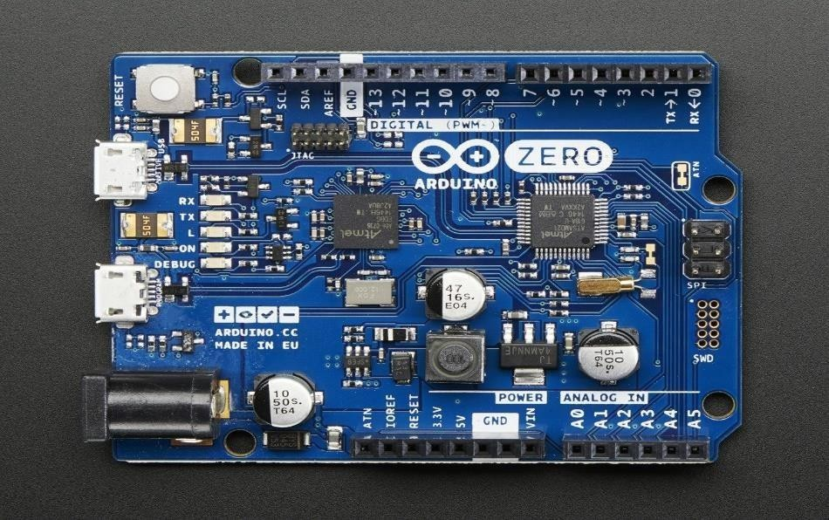

Fig 4.7 Arduino Uno

- IR sensor:-

An Infrared (IR) sensor is a device that detects infrared radiation, which is emitted by objects in the form of heat. IR sensors are widely used in various applications, ranging from simple motion detection to complex environmental sensing systems. They operate based on the principle that all objects above absolute zero emit infrared radiation, with the intensity of the radiation increasing with temperature.
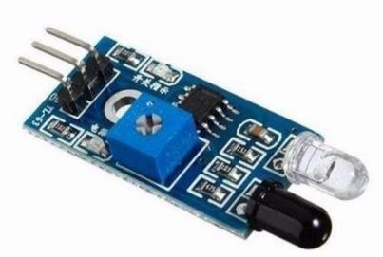

Fig 4.8 IR Sensor

- Ultrasonic sensor

Ultrasonic sensor working principle is either similar to sonar or radar which evaluates the target/object attributes by understanding the received echoes from sound/radio waves correspondingly. These sensors produce high-frequency sound waves and analyze the echo which is received from the sensor. The sensors measure the time interval between transmitted and received echoes so that the distance to the target is known.

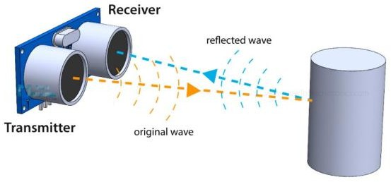

Fig 4.9 Ultrasonic Sensor

- Piezo sensor:-

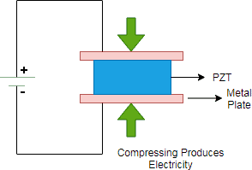
Piezo is a Greek term signifying “press” or “squeeze”. Piezoelectricity (also called the piezoelectric effect) is the presence of an electrical potential across the sides of a crystal when mechanical stress is applied by squeezing it. In working system, the crystal acts like a tiny battery with a positive charge on one face and a negative charge on the opposite face. To make it as a complete circuit, two faces are connected together and current is passed through it.

Fig 4.10 Piezoelectric Sensor

- 12V DC motor
These motors are compact and efficient, providing good torque and speed for driving wheels or mechanisms. They are easy to control with an H-bridge or motor driver, allowing for forward and reverse movement. The 12V rating provides a balance between power and energy efficiency, making them ideal for mid-sized robotic platforms or small vehicles.
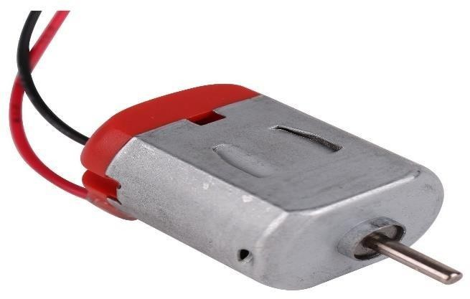

Fig 4.11 DC motor

- L293D motor driver

The L293D motor driver module is an integrated circuit used to control the speed and direction of DC motors. It can handle two DC motors or one stepper motor, allowing independent control of each. The module has built-in H-bridges, enabling motors to run forward or in reverse. It's compatible with microcontrollers like Arduino, making it popular for robotics projects. The L293D can drive motors up to 36V and 600mA per channel, providing reliable and simple motor control for small to medium-sized projects.
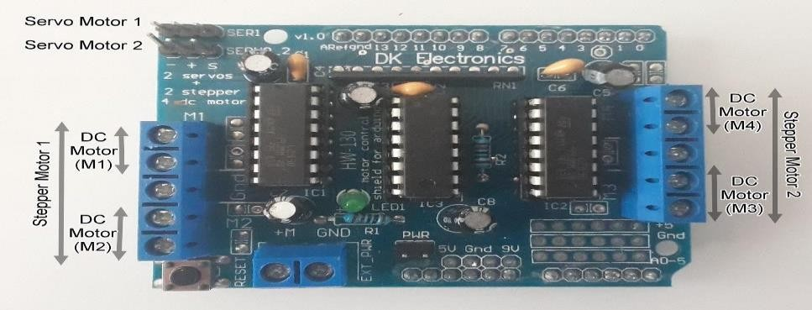

Fig 4.12 L293D motor drive

- A water Motor Pump

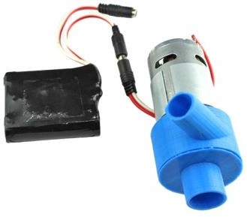
A water motor pump is a device that moves water from one place to another using a motor- driven mechanism. It is commonly used in irrigation, drainage, and water supply systems. These pumps can vary in size and power, with some designed for small electronics projects and others for large-scale industrial use. Typically powered by electricity, water motor pumps can handle various fluids, providing a consistent and controlled flow.

Fig 4.13 Water Motor Pump

They are valued for their efficiency in moving water and ease of automation in both DIY and professional application.

Water container

A water container is a vessel used to store and transport water. Common types include plastic, metal, ceramic, and collapsible containers, available in various sizes. They are made from materials like food-grade plastic, glass, and stainless steel for safe storage. Water containers are widely used in households, industries, and agriculture for water conservation and distribution.

Switchs
An electric switch is an important component in an electrical circuit. An electric switch is a simple device that either breaks the circuit or completes it to stop or start the flow of current. An electric switch is an arrangement to switch the circuit ON and OFF as needed. It is also called a “Key” component in an electrical circuit. Basically, it is used to interrupt the general flow of
electrons. In this article we will learn about Electric switches, the Working of electric switches, the construction of electric switches and different types of electric switches
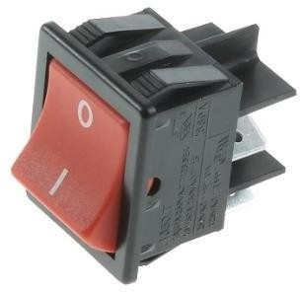

Fig 4.14 Switch

- Jumper wires

Jumper wires are flexible electrical wires used to make connections between different components on a breadboard or circuit. They come with pre-attached connectors, typically male-to-male, male- to-female, or female-to-female, making it easy to link microcontrollers, sensors, and other devices without soldering. Jumper wires are commonly used in prototyping and testing circuits.

Gears

When one gear (the driver) turns, its teeth push against the teeth of the next gear (the driven gear), causing it to rotate. The size and number of teeth on each gear affect the speed and torque of rotation.
- Torque: Force of rotation

- Speed: How fast the gear turns

- Direction: Each gear usually reverses the direction of motion.
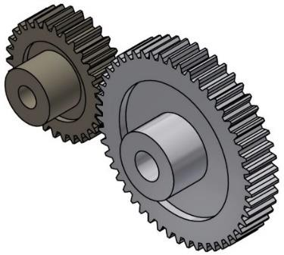

Fig 4.15 Gear

- Solar Pannel

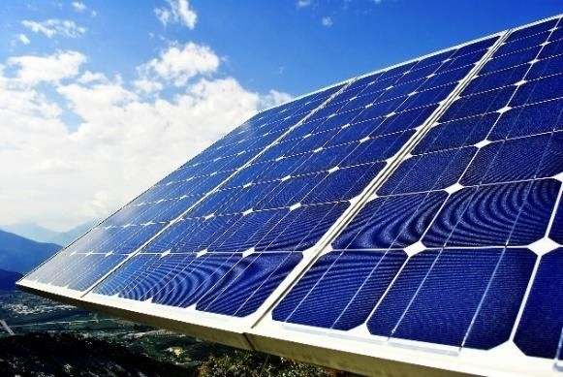
A solar panel is a device that converts sunlight into electricity using a process called the photovoltaic effect.Photovoltaic (PV) Cells inside the panel absorb light.

Fig 4.16 Solar pannel

They generate direct current (DC) electricityThat electricity can charge batteries or power small device.

LCD 16 X 2

A 16x2 LCD display is a liquid crystal display that can show 2 lines of 16 characters each, hence the name "16x2". It uses the HD44780 driver (or compatible) and displays alphanumeric text and simple custom characters. The LCD receives data and commands from a microcontroller (like an Arduino):
- Commands: Move cursor, clear screen, shift display, etc.
- Data: Characters to display.
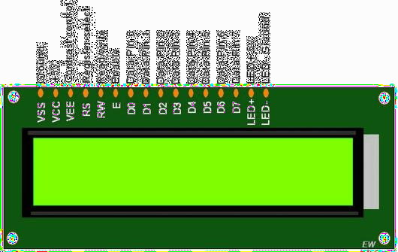

Fig 4.17 LCD Display

- LM358 Comparator

The LM358 is a dual operational amplifier (op-amp) IC. When used in comparator mode, it compares two input voltages and outputs either HIGH or LOW, depending on which input is greater.
It's called a "comparator" when used not to amplify, but to compare voltages and give a digital output (ON/OFF).
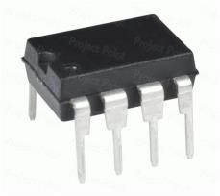

Fig 4.18 LM358 Comparator IC

- LED

An LED (Light Emitting Diode) is a semiconductor device that emits light when current flows through it. Unlike incandescent bulbs, LEDs are energy-efficient, produce very little heat, and last thousands of hours.
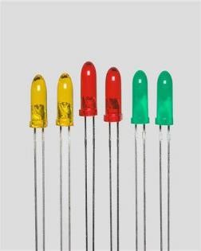

Fig 4.19 LED

CHAPTER 5 : SYSTEM IMPLEMENTATION
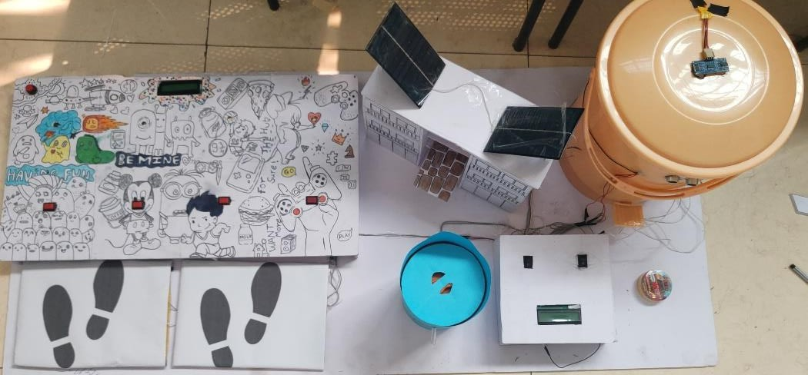

Fig 5.1 System diagram

The working of an agriculture robot involves a series of interconnected systems designed for specific tasks in farming. Here's a detailed breakdown of how it works:

Perception and Data Collection

Sensors: A smart hub system are equipped with sensors like IR, ultrasonic sensors and Piezoelectric Sensor.
Purpose: These sensors collect real-time data about the Level of dust, obstacle and force convert into electricity with sensor.
Processing: Collected data is will compare and then process to give some output in terms of ultrasonic and IR , and generated electricity get stored in Battery in terms of Piezoelectric sensors.

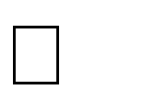
Task Execution Research & Planning
  - Identify components: sensors, controllers, power units.
  - Finalize architecture for dustbin, footstep power, game, and ads.
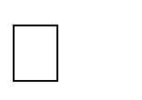
Hardware Setup
  - Install piezo plates for footstep energy.
  - Set up ultrasonic sensors and servo for smart dustbin.
  - Connect load sensor, water pump, and dispenser.


Software Development
  - Code microcontroller for sensor control and logic flow.

  - Develop child memory game interaction.
  - Build cloud-based ad display system.


Integration
  - Combine all modules into a single functional unit.
  - Ensure smooth power sharing and data flow.


Testing & Debugging
  - Test in simulated real-world settings.
  - Fix timing, power, and sensor detection issues.


Deployment & Demo
  - Install in a public trial area.
  - Demonstrate all features working together.

Communication and Reporting

Data Transmission: The System sends data to a cloud-based platform or a local control system for further analysis.
Insights: Peoples can access this data through mobile or desktop applications to monitor progress and make informed decisions.

Power and Mobility

Energy Source: System Applications are powered by batteries, solar panels, footstep Electricity generator to ensure sustainability.
Mobility: Equipped with wheels, tracks, or drones (for aerial applications) for movement across different terrains.

5.2 Arduino IDE Software working:

- Download and Install Arduino IDE: If you haven't already, download and install the Arduino IDE from the official Arduino website.
- Open Arduino IDE: Launch the Arduino IDE software on your computer.
- Connect Arduino Board: Connect your Arduino board to your computer using a USB cable.
- Select Board:Go to Tools > Board and select the type of Arduino board you're using (e.g., Arduino Uno, Arduino Nano, etc.).
- Select Port: Go to Tools > Port and select the port to which your Arduino board is connected. If you're unsure, you can check this in your computer's device manager.
- Create a New Sketch: Click on File > New to create a new sketch.
- Write Code: Write your Arduino code in the editor window. Arduino code consists of two main parts: setup() and loop(). The setup() function is called once when the board is powered on or reset, and the loop() function runs continuously after that. Write your initialization code in setup() and the main functionality of your project in loop().
- Verify/Compile Code: Click on the checkmark icon (or go to Sketch > Verify/Compile) to compile your code. This step checks for any syntax errors in your code.
- Upload Code: Once your code compiles successfully, click on the right arrow icon (or go to Sketch> Upload) to upload the code to your Arduino board. The code will be compiled again and then uploaded to the board.
- Monitor Serial Output (Optional):If your code includes serial communication, you can monitor the output in the Serial Monitor window. Go to Tools > Serial Monitor, or press Ctrl+Shift+M.
- Debug and Test: After uploading the code, test your Arduino project to ensure it's
working as expected. If there are any issues, you can debug and modify your code accordingly.
- Save Code: Once you're satisfied with your code, save it by clicking on File > Save or pressing Ctrl+S.

Program a)
#include<LiquidCrystal_I2C.h> LiquidCrystal_I2C lcd(0x27, 16, 2);
const int ledPins[4] = {2, 3, 4, 5}; // LED pins
const int buttonPins[4] = {6, 7, 8, 9}; // Button pins int sw = 10;
int score = 0; // Player's score

void setup() { Serial.begin(9600);
for (int i = 0; i < 4; i++) { pinMode(ledPins[i], OUTPUT); pinMode(buttonPins[i], INPUT_PULLUP);
}
pinMode(sw, INPUT); lcd.init(); lcd.backlight(); lcd.setCursor(0,0); lcd.print("Map Your"); lcd.setCursor(0,1);
lcd.print("Brain Here..."); delay(2000);
lcd.clear();
}

void loop() {
int state = digitalRead(sw); Serial.println(state);
if (state == 1) { score = 0; lcd.clear();
lcd.print("Starting game"); delay(2000);
lcd.clear();

for (int attempt = 5; attempt > 0; attempt--) { lcd.setCursor(0,0);
lcd.print("Attempt: "); lcd.print(attempt); delay(1000); lcd.clear();

int randomIndex = random(0, 4); // Pick a random LED index digitalWrite(ledPins[randomIndex], HIGH);
unsigned long startTime = millis(); bool buttonPressed = false;

pressed
while (millis() - startTime < 1000) {
if (digitalRead(buttonPins[randomIndex]) == HIGH) { // If correct button is

buttonPressed = true; score++;
Serial.print("Correct! Score: "); Serial.println(score); lcd.setCursor(0,0); lcd.print("Correct!"); lcd.setCursor(0,1); lcd.print("Score: "); lcd.print(score);
delay(1000); lcd.clear(); break;

}
}

digitalWrite(ledPins[randomIndex], LOW); // Turn off LED

if (!buttonPressed) { Serial.println("Missed!");

lcd.setCursor(0,0); lcd.print("Missed!"); lcd.setCursor(0,1); lcd.print("Try again."); delay(1000); lcd.clear();
}
}

lcd.setCursor(0,0); lcd.print("Game Over!"); lcd.setCursor(0,1); lcd.print("Final Score: "); lcd.print(score); delay(3000);
lcd.clear();
}
}

b)
#include<LiquidCrystal_I2C.h> LiquidCrystal_I2C lcd(0x27, 16,2);

#define trigPin1 2
#define echoPin1 3
#define trigPin2 4
#define echoPin2 5 int in1 = 6;
int in2 = 7; int ir = 10; int relay = 8;
int load = A0;
long duration, distance, dist1,dist2, dist3;

void setup() { lcd.init(); lcd.backlight();

Serial.begin (9600); pinMode(trigPin1, OUTPUT); pinMode(echoPin1, INPUT); pinMode(trigPin2, OUTPUT); pinMode(echoPin2, INPUT); pinMode(ir, INPUT); pinMode(in1, OUTPUT); pinMode(in2, OUTPUT); pinMode(relay, OUTPUT); digitalWrite(relay,HIGH); pinMode(load, INPUT);
Serial.println(" ");
lcd.setCursor(0,0); lcd.print("Smart Dustbit");

lcd.setCursor(0,1); lcd.print("Use Me ");
delay(2000); lcd.clear();

}

void loop() {
SonarSensor(trigPin1, echoPin1); dist1 = distance;

SonarSensor(trigPin2, echoPin2); dist2 = distance; lcd.setCursor(0,0); lcd.print("Dustbin Level "); lcd.setCursor(0,1); lcd.print(dist2);
delay(300); lcd.clear();

int vtg = analogRead(vtg); Serial.print("Object is at "); Serial.println(dist1); Serial.print("load cell load is "); vtg = 1023 - vtg; Serial.println(vtg);
if(vtg> 0)
{
lcd.setCursor(0,0); lcd.print("Voltage in"); lcd.setCursor(0,1); lcd.print(vtg*1000); lcd.print(" mVolt"); delay(500);

lcd.clear();
}

if(dist1 < 12)
{

lcd.print("opening Dustbin"); digitalWrite(in1,HIGH); digitalWrite(in2, LOW); delay(3000);
lcd.clear(); lcd.setCursor(0,0); lcd.print("deposit trash"); lcd.setCursor(0,1); lcd.print("in dustbin"); digitalWrite(in1, LOW); digitalWrite(in2, LOW); delay(3000);
lcd.clear(); lcd.setCursor(0,0); lcd.print("closing.."); lcd.setCursor(0,1); lcd.print("thank you...");

digitalWrite(in1,LOW); digitalWrite(in2, HIGH); delay(3000);
lcd.clear(); digitalWrite(in1, LOW); digitalWrite(in2, LOW); delay(1000); lcd.setCursor(0,0); lcd.print("Dispensing.."); lcd.setCursor(0,1); lcd.print("cold drink...");

delay(2000); lcd.clear();
Serial.println("dispancing water"); dispanceWater();

}

else
{
digitalWrite(in1, LOW); digitalWrite(in2, LOW);

}
Serial.print("dustbin level is "); Serial.println(dist2); delay(100);

}
void SonarSensor(int trigPin,int echoPin)
{
digitalWrite(trigPin, LOW); delayMicroseconds(2); digitalWrite(trigPin, HIGH); delayMicroseconds(10); digitalWrite(trigPin, LOW); duration = pulseIn(echoPin, HIGH); distance = (duration/2) / 29.1;

}
void dispanceWater()
{
digitalWrite(relay, LOW); delay(10000); digitalWrite(relay,HIGH);
}

CHAPTER 6 : RESULTS AND APPLICATIONS
Results
- Footstep Energy Generation:
  - Successfully generated voltage using piezoelectric sensors from human footsteps.
  - Voltage output varied with weight and frequency of steps (~1.5V–3.5V per step with load).

Smart Dustbin Functionality:
  - Ultrasonic sensor accurately detected presence within 12 cm.
  - Dustbin lid opened and closed automatically.
  - Water pump and liquid dispenser worked reliably after trash disposal.

Interactive Child Game:
  - Memory-matching game activated via switch.
  - LEDs responded correctly to user input.
  - Game powered by harvested footstep energy in test runs.

Smart Advertisement Display:
  - Display system pulled ads from a simulated cloud-based source.
  - Dynamic ads were shown based on availability status.
  - Responsive and remotely updateable.

Overall Integration:
  - All systems (dustbin, game, ad, and energy) operated in sync.
  - Efficient energy usage observed with piezo storage buffer.
  - User-friendly and functional in a controlled environment.

Applications
- Public Spaces:
  - Malls, hospitals, schools, airports for clean waste disposal and energy-saving solutions.

Smart Cities:
  - Integration into smart infrastructure for sustainable urban development.

Education & Entertainment:
  - Promotes physical activity and learning through interactive gaming for kids.

Marketing & Advertisement:
  - Cost-effective, AI-based ad solution for businesses, especially startups.

Environmental Awareness:
  - Encourages eco-friendly practices and highlights energy conservation.

CHAPTER 7 : FUTURE SCOPE AND CONCLUSION

Conclusion

This project successfully demonstrates a multi-functional smart system that integrates footstep- based energy harvesting, automated waste management, interactive gaming, and smart advertising. It not only promotes sustainability and cleanliness but also enhances public engagement through interactive technology. With its adaptable design and future-ready components, this system holds strong potential for real-world deployment in smart cities and public infrastructures.

Advantages

- Eco-Friendly Power – Generates and stores electricity using footsteps and solar energy, reducing reliance on traditional power sources.
- Smart Waste Management – Encourages hygienic and interactive garbage disposal with automatic dustbin operation and rewards.
- Child-Friendly Learning – Offers fun games that improve memory and learning while engaging kids with tech.
- Digital Advertising Platform –Provides a simple, low-cost way for small businesses to display ads in high-traffic areas.
- Fully Automated System – Uses sensors and microcontrollers for seamless, hands-free operation across all modules.

Limitation


Limited Power Generation – Footstep energy may not generate enough power in low-traffic areas.
Sensor Sensitivity Issues – Sensors may misread or fail in dusty, wet, or highly crowded environments.

Dependency on Human Interaction – Some features (like ad booking or dustbin operation) rely on user engagement, which can vary.

Future Scope

- Hybrid Energy Integration:

  - Add solar panels alongside footstep energy to boost power generation and storage efficiency.

- AI & IoT Connectivity:

  - Use real-time data monitoring and cloud analytics for smarter waste management and advertisement targeting.
- Mobile App Control:

  - Develop a companion mobile dashboard for remote monitoring, game updates, and ad scheduling.
- Scalability:

  - Expand implementation in transport hubs, smart roads, parks, and healthcare centers.

- Incentive-Based Use:

  - Integrate rewards or points system to encourage public participation in waste disposal and energy generation.

Chapter 8 - Reference and Bibliography

BIBLIOGRAPHY

Sharma & Jain – Footstep energy using piezo sensors Kaur & Singh – IoT-based smart waste management Saini & Goel – Smart dustbin using Arduino and sensors Ghosh & Das – Energy harvesting from human footsteps Khan & Pathan – AI-driven smart advertising systems

REFERENCE.

- https://www.geeksforgeeks.org/project-idea-smart-waste-management-system

- https://ijcrt.org/papers/IJCRT2410112.pdf

Chapter 9 - Appendix

Sr. No | Name of Figure | PRICE
1 | Arduino | 600/-
2 | Arduino Nano | 300/-
3 | Gears | 100/-
4 | DC motor | 180/-
5 | L293D motor driver | 150/-
6 | Water motor pump | 80/-
7 | Water Container | 35/-
8 | Ultrasonic | 160/-
9 | Battery | 200/-
10 | Piezo Sensors | 400/-
11 | Jumper Wires | 100/-
12 | Relay module | 80/-
13 | Resitors | 50/-
14 | Lm358 comparator ckt | 50/-
15 | Dustbin | 220/-
16 | Batter holder | 55/-
17 | LED’s | 35/-
18 | Firm shit | 480/-
19 | Switches | 35/-
20 | LCD 16X2 | 400/-
21 | IR | 50/-
TOTAL |  | 3760/-

